**Assignment-based Subjective Questions**

**1. From your analysis of the categorical variables from the dataset, what could you infer about**

**their effect on the dependent variable? (3 marks)**

Answer: The analysis of categorical variables showed the following observations:

1. Demand for bike sharing is more during summer, fall and winter seasons. Fall being the highest demand for bike sharing and spring season has lowest demand.
2. Months ranging from May to October is the peak period. During this period there is huge demand for bike sharing.
3. People do bike sharing more during Clear weather conditions. This also shows people are more concerned about the safe climate conditions. Bike sharing might be dangerous during bad weather.
4. There is no significant difference of bookings based on weekend but it seems Sunday and Monday are the days which attracted lowest booking compared to the other days.
5. Bike bookings are more during working days compared to a holiday. Maybe some people prefer to travel with family during holidays and hence opt less for a bike sharing option.
6. There is a approximately 50% rise in the bookings in the year 2019 compared to the year 2018. This shows that more people are shifting towards bike sharing model to save on fuel cost.

**2. Why is it important to use drop_first=True during dummy variable creation? (2 mark)**

Answer: The definition of drop_first=True in panda library is given as below:

**drop_firstbool, default False**

Whether to get k-1 dummies out of k categorical levels by removing the first level.

As we see above the default value is false. Hence it is important to set this value to true in order to reduce its correlation among the dummy variables created.

**3. Looking at the pair-plot among the numerical variables, which one has the highest correlation**

**with the target variable? (1 mark)**

Answer: Both the pair-plot as well as the heat map show that temp column has the highest correlation with the target variable.

**4. How did you validate the assumptions of Linear Regression after building the model on the**

**training set? (3 marks)**

Answer: I have validated the assumptions of Linear Regression through below observations in my analysis:

1. Linear relationship: Linear relationship is observed among the dependent and target variables.
2. Multicollinearity check: There should be insignificant multicollinearity among variables. For e.g. I dropped atemp variable to remove the multicollinearity effect.
3. Normality of error terms: Error terms are normally distributed.
4. Independence of residuals: No auto correlations observed.
5. Homoscedasticity: There is no visible pattern in residual values.

**5. Based on the final model, which are the top 3 features contributing significantly towards**

**explaining the demand of the shared bikes? (2 marks)**

Answer: Based on the final model, the top 3 features contributing significantly towards explaining the demand of the shared bikes are:

1. Temperature: This variable shows the highest positive correlation.
2. Light_snowrain: This variable shows a negative correlation. Which means people avoid bike sharing if there are predictions of snow rains.
3. Wind speed: This variable also shows a negative correlation because people fear accidents due to high wind speed.

**General Subjective Questions**

**1. Explain the linear regression algorithm in detail. (4 marks)**

**Answer:** Linear regression may be defined as the statistical model that analyses the linear relationship between a dependent variable with given set of independent variables. Linear relationship between variables means that when the value of one or more independent variables will change (increase or decrease), the value of dependent variable will also change accordingly (increase or decrease).

Mathematically the relationship can be represented with the help of following equation −

Y = mX + c

Here, Y is the dependent variable we are trying to predict.

X is the independent variable we are using to make predictions.

m is the slope of the regression line which represents the effect X has on Y c is a constant, known as the Y-intercept. If X = 0, Y would be equal to c.

Furthermore, the linear relationship can be positive or negative in nature as explained below−

* + Positive Linear Relationship:
    - A linear relationship will be called positive if both independent and dependent variable increases. It can be understood with the help of following graph −

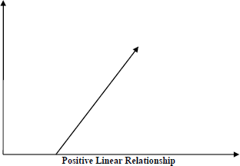

* + Negative Linear relationship:
    - A linear relationship will be called positive if independent increases and dependent variable decreases. It can be understood with the help of following graph −

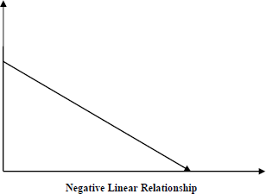

Linear regression is of the following two types −

a) Simple Linear Regression

b) Multiple Linear Regression

Assumptions -

The following are some assumptions about dataset that is made by Linear Regression model −

ü Multi-collinearity –

o Linear regression model assumes that there is very little or no multi-collinearity in the data. Basically, multi-collinearity occurs when the independent variables or features have dependency in them.

ü Auto-correlation –

o Another assumption Linear regression model assumes is that there is very little or no auto-correlation in the data. Basically, auto-correlation occurs when there is dependency between residual errors.

ü Relationship between variables –

o Linear regression model assumes that the relationship between response and feature variables must be linear.

ü Normality of error terms –

o Error terms should be normally distributed

ü Homoscedasticity –

o There should be no visible pattern in residual values.

**2. Explain the Anscombe’s quartet in detail. (3 marks)**

**Answer:** Anscombe’s Quartet was developed by statistician Francis Anscombe. It comprises four

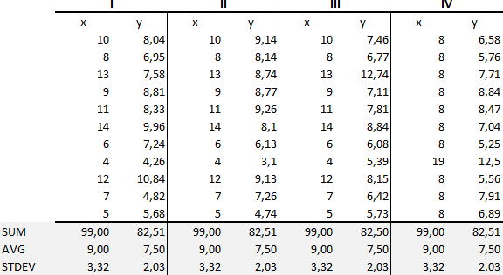datasets, each containing eleven (x, y) pairs. The essential thing to note about these datasets is that they share the same descriptive statistics. But things change completely, and I must emphasize COMPLETELY, when they are graphed. Each graph tells a different story irrespective of their similar summary statistics.

The summary statistics show that the means and the variances were identical for x and y across the groups:

* Mean of x is 9 and mean of y is 7.50 for each dataset.
* Similarly, the variance of x is 11 and variance of y is 4.13 for each dataset
* The correlation coefficient (how strong a relationship is between two variables) between x and y is 0.816 for each dataset

When we plot these four datasets on an x/y coordinate plane, we can observe that they show the same regression lines as well but each dataset is telling a different story:

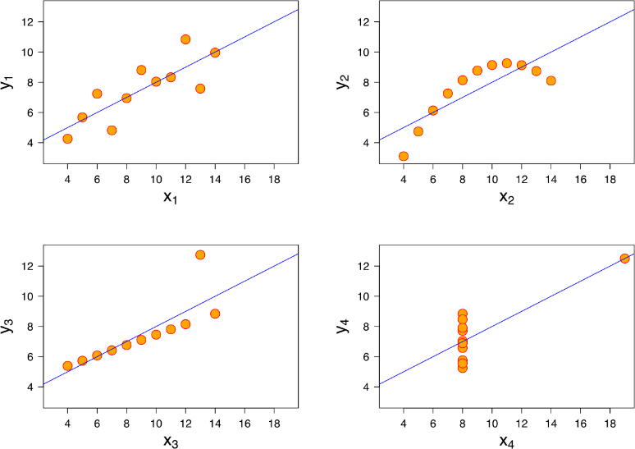

* Dataset I appear to have clean and well-fitting linear models.
* Dataset II is not distributed normally.
* In Dataset III the distribution is linear, but the calculated regression is thrown off by an outlier.
* Dataset IV shows that one outlier is enough to produce a high correlation coefficient.

This quartet emphasizes the importance of visualization in Data Analysis. Looking at the data reveals a lot of the structure and a clear picture of the dataset.

**3. What is Pearson’s R? (3 marks)**

**Answer**: Pearson's r is a numerical summary of the strength of the linear association between the variables. If the variables tend to go up and down together, the correlation coefficient will be positive. If the variables tend to go up and down in opposition with low values of one variable associated with high values of the other, the correlation coefficient will be negative.

The Pearson correlation coefficient, r, can take a range of values from +1 to -1. A value of 0 indicates that there is no association between the two variables. A value greater than 0 indicates a positive association; that is, as the value of one variable increases, so does the value of the other variable. A value less than 0 indicates a negative association; that is, as the value of one variable increases, the value of the other variable decreases. This is shown in the diagram below:

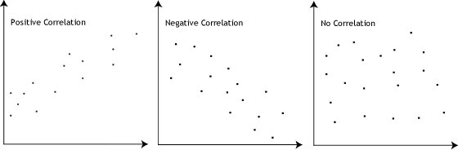

**4. What is scaling? Why is scaling performed? What is the difference between normalized scaling**

**and standardized scaling? (3 marks)**

**Answer:**

Feature Scaling is a technique to standardize the independent features present in the data in a fixed range. It is performed during the data pre-processing to handle highly varying magnitudes or values or units. If feature scaling is not done, then a machine learning algorithm tends to weigh greater values, higher and consider smaller values as the lower values, regardless of the unit of the values.

Example**:** If an algorithm is not using feature scaling method then it can consider the value 3000 meter to be greater than 5 km but that’s actually not true and in this case, the algorithm will give

wrong predictions. So, we use Feature Scaling to bring all values to same magnitudes and thus, tackle this issue.

|  |  |  |
| --- | --- | --- |
| S.NO. | Normalized scaling | Standardized scaling |
| 1. | Minimum and maximum value of features are used for scaling | Mean and standard deviation is used for scaling. |
| 2. | It is used when features are of different scales. | It is used when we want to ensure zero mean and unit standard deviation. |
| 3. | Scales values between [0, 1] or [-1, 1]. | It is not bounded to a certain range. |
| 4. | It is really affected by outliers. | It is much less affected by outliers. |
| 5. | Scikit-Learn provides a transformer called MinMaxScaler for Normalization. | Scikit-Learn provides a transformer  called StandardScaler for standardization. |

**5. You might have observed that sometimes the value of VIF is infinite. Why does this happen?**

**(3 marks)**

## Answer:

If there is perfect correlation, then VIF = infinity. A large value of VIF indicates that there is a correlation between the variables. If the VIF is 4, this means that the variance of the model coefficient is inflated by a factor of 4 due to the presence of multicollinearity.

When the value of VIF is infinite it shows a perfect correlation between two independent variables. In the case of perfect correlation, we get R-squared (R2) =1, which lead to 1/ (1-R2) infinity. To solve this we need to drop one of the variables from the dataset which is causing this perfect multicollinearity.

**6. What is a Q-Q plot? Explain the use and importance of a Q-Q plot in linear regression.**

**(3 marks)**

## Answer:

The quantile-quantile (q-q) plot is a graphical technique for determining if two data sets come from populations with a common distribution.

Use of Q-Q plot:

A q-q plot is a plot of the quantiles of the first data set against the quantiles of the second dataset. By a quantile, we mean the fraction (or percent) of points below the given value. That is, the 0.3 (or 30%) quantile is the point at which 30% percent of the data fall below and 70% fall above that value. A 45-degree reference line is also plotted. If the two sets come from a population with the same distribution, the points should fall approximately along this reference line. The greater the departure from this reference line, the greater the evidence

for the conclusion that the two data sets have come from populations with different distributions.

Importance of Q-Q plot:

When there are two data samples, it is often desirable to know if the assumption of a common distribution is justified. If so, then location and scale estimators can pool both data sets to obtain estimates of the common location and scale. If two samples do differ, it is also useful to gain some understanding of the differences. The q-q plot can provide more insight into the nature of the difference than analytical methods such as the chi-square and Kolmogorov-Smirnov 2-sample tests.